Below is a step-by-step guide to install PostgreSQL on your PC and connect it with DBeaver, along with links and tips for solving common issues.

Links that will help –

Install – Postgres - [https://www.youtube.com/watch?v=4qH-7w5LZsA](https://www.youtube.com/watch?v=4qH-7w5LZsA&t=186s)

Load sample database - <https://www.youtube.com/watch?v=3iiw46_uIZ8>

Psql explanation - [https://www.youtube.com/watch?v=5kPFhTqlRIE](https://www.youtube.com/watch?v=5kPFhTqlRIE&t=222s)

**1. Install PostgreSQL**

**a. Download PostgreSQL**

* **Official PostgreSQL Downloads Page:**  
  <https://www.postgresql.org/download/>
* **For Windows:**  
  You can use the [EnterpriseDB installer](https://www.enterprisedb.com/downloads/postgres-postgresql-downloads) which is straightforward and bundles useful tools like pgAdmin.

**b. Run the Installer**

1. **Launch the Installer:** Download and run the installer.
2. **Follow the Setup Wizard:**
   * **Choose Installation Directory:** Accept the default or set your own.
   * **Select Components:** It’s recommended to install PostgreSQL Server, pgAdmin, and command line tools.
   * **Set Superuser Password:** Remember this password; you’ll need it later.
   * **Default Port:** PostgreSQL uses port 5432 by default. You can change this if needed.
3. **Complete Installation:** Finish the wizard and let the installer start the PostgreSQL service.

**c. Verify Installation**

* **Using pgAdmin:** Open pgAdmin (installed alongside PostgreSQL) to ensure your server is running.
* **Using Command Line:**  
  Open Command Prompt or PowerShell and run:
* psql -U postgres

Then enter your password when prompted.

**d. Import Data bases**

* **Set up Bin Path:** on the task bar (top right of the screen) go to **File -> References -> Path -> Binary Paths**
* **Find path to bin folder:**  looks something like this - **C:\Program Files\PostgreSQL\17\bin**
* **Paste in Bin Path:** 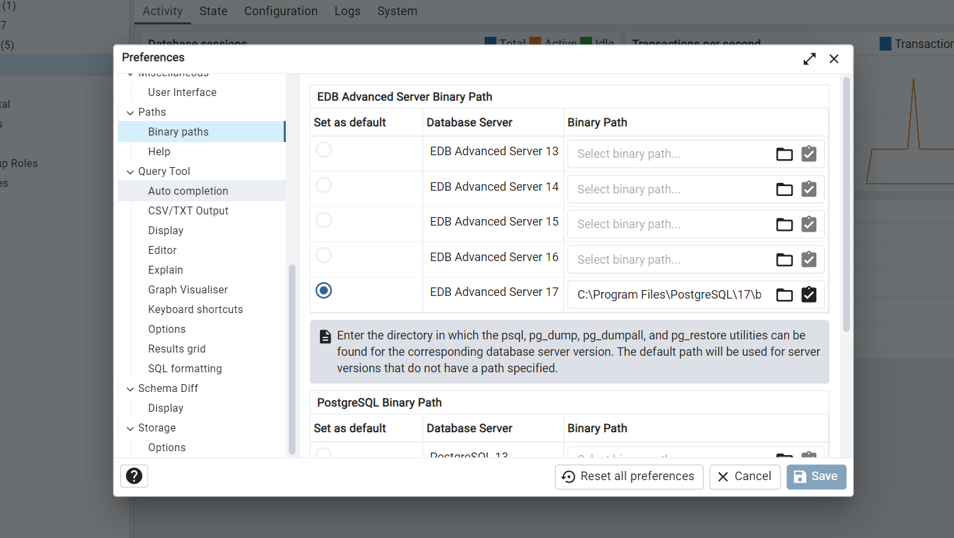
* **Download Databases from github:** go to - <https://github.com/chris-win/SQL_0to100_in-16_hours/tree/main/Session%201/Database%20Files> and download the files (you will have 4 files - 1 .tar file and 3 .sql files)
* **For each database:** 
  + **Create a Database in pgAdmin:** Right click on a server and create database (for example dvd_rental) this will create an empty database
  + **Load Data:** To load date right click on the empty database and click **“Restore”** select file and click restore
  + **If the above restore doesn’t work:** Open Command Prompt change directory to the Bin path we have previously set up the command will look like this -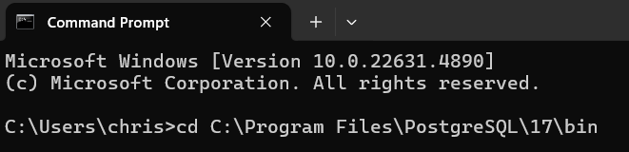
  + Then find the path of the file and keep it ready
  + **Type the below command**
  + 
  + psql is the program we are accessing, after the -h argument provide the website name, after the -d argument provide the database name, after the -U argument provide the user name, after the -p argument provide the port, after that use < and provide file path without quotes
  + Provide the password for the user and then the database will load
  + You can check it in your pgAdmin 4 program

**2. Install DBeaver**

**a. Download DBeaver**

* **Official DBeaver Download Page:**  
  <https://dbeaver.io/download/>
* **Community Edition:**  
  This is free and sufficient for connecting to PostgreSQL.

**b. Run the DBeaver Installer**

1. **Launch the Installer:** Download and run the DBeaver installer.
2. **Follow the Setup Instructions:** Accept the license and install in your preferred directory.
3. **Launch DBeaver** once the installation is complete.

**3. Connect PostgreSQL with DBeaver**

**a. Create a New Connection**

1. **Open DBeaver.**
2. **Click on "New Database Connection"** (usually a plug icon or via the Database menu).
3. **Select PostgreSQL:**  
   You might see it listed directly. If not, use the search bar to filter.
4. **Enter Connection Details:**
   * **Host:** localhost (or your server’s IP address)
   * **Port:** 5432 (unless you changed it during installation)
   * **Database:** Typically postgres (or any other database you created)
   * **Username:** postgres (or another user you’ve configured)
   * **Password:** The one you set during installation

**b. Test the Connection**

* Click on **"Test Connection"** to check if DBeaver can connect to PostgreSQL.
* If the test is successful, click **"Finish"** to complete the setup.

**4. Potential Issues & Fixes**

**a. Connection Refused / Firewall Issues**

* **Issue:**  
  You might see an error like "Connection refused" or "timeout".
* **Fix:**
  + **Verify PostgreSQL is Running:** Use pgAdmin or check the services.
  + **Firewall Settings:**  
    Ensure that port 5432 is allowed through your firewall.
  + **Network Configuration:**  
    If connecting from another machine, check postgresql.conf (for listen_addresses) and pg_hba.conf for proper host-based authentication entries.

**b. Authentication Failures**

* **Issue:**  
  Errors such as “password authentication failed” or “role does not exist”.
* **Fix:**
  + **Verify Credentials:** Double-check the username and password you’re entering.
  + **Role Configuration:**  
    Ensure the role (user) exists in PostgreSQL. You can create a new user if needed:
  + CREATE ROLE your_username WITH LOGIN PASSWORD 'your_password';
  + **pg_hba.conf:**  
    Make sure the authentication method (e.g., md5) is correctly set for your connection type.

**c. Driver or SSL Errors in DBeaver**

* **Issue:**  
  Sometimes DBeaver might prompt for additional driver downloads or SSL settings.
* **Fix:**
  + **Download Driver:**  
    DBeaver usually offers to download the missing PostgreSQL JDBC driver automatically.
  + **SSL Settings:**  
    If connecting over SSL, ensure that you have the proper certificates and that SSL settings in DBeaver match your PostgreSQL configuration.

**5. Additional Resources**

* **PostgreSQL Documentation:**  
  <https://www.postgresql.org/docs/>
* **DBeaver Documentation:**  
  <https://dbeaver.com/docs/>
* **Troubleshooting Guides:**
  + [PostgreSQL FAQ](https://www.postgresql.org/docs/current/faq.html)
  + [DBeaver Community Forum](https://dbeaver.io/forum/)

By following these steps and using the provided resources, you should be able to install PostgreSQL on your PC and successfully connect to it using DBeaver. If you run into any issues, check the logs in both PostgreSQL and DBeaver and refer to the documentation for more detailed troubleshooting.